KENNY NGUYEN

BIOGRAPHY

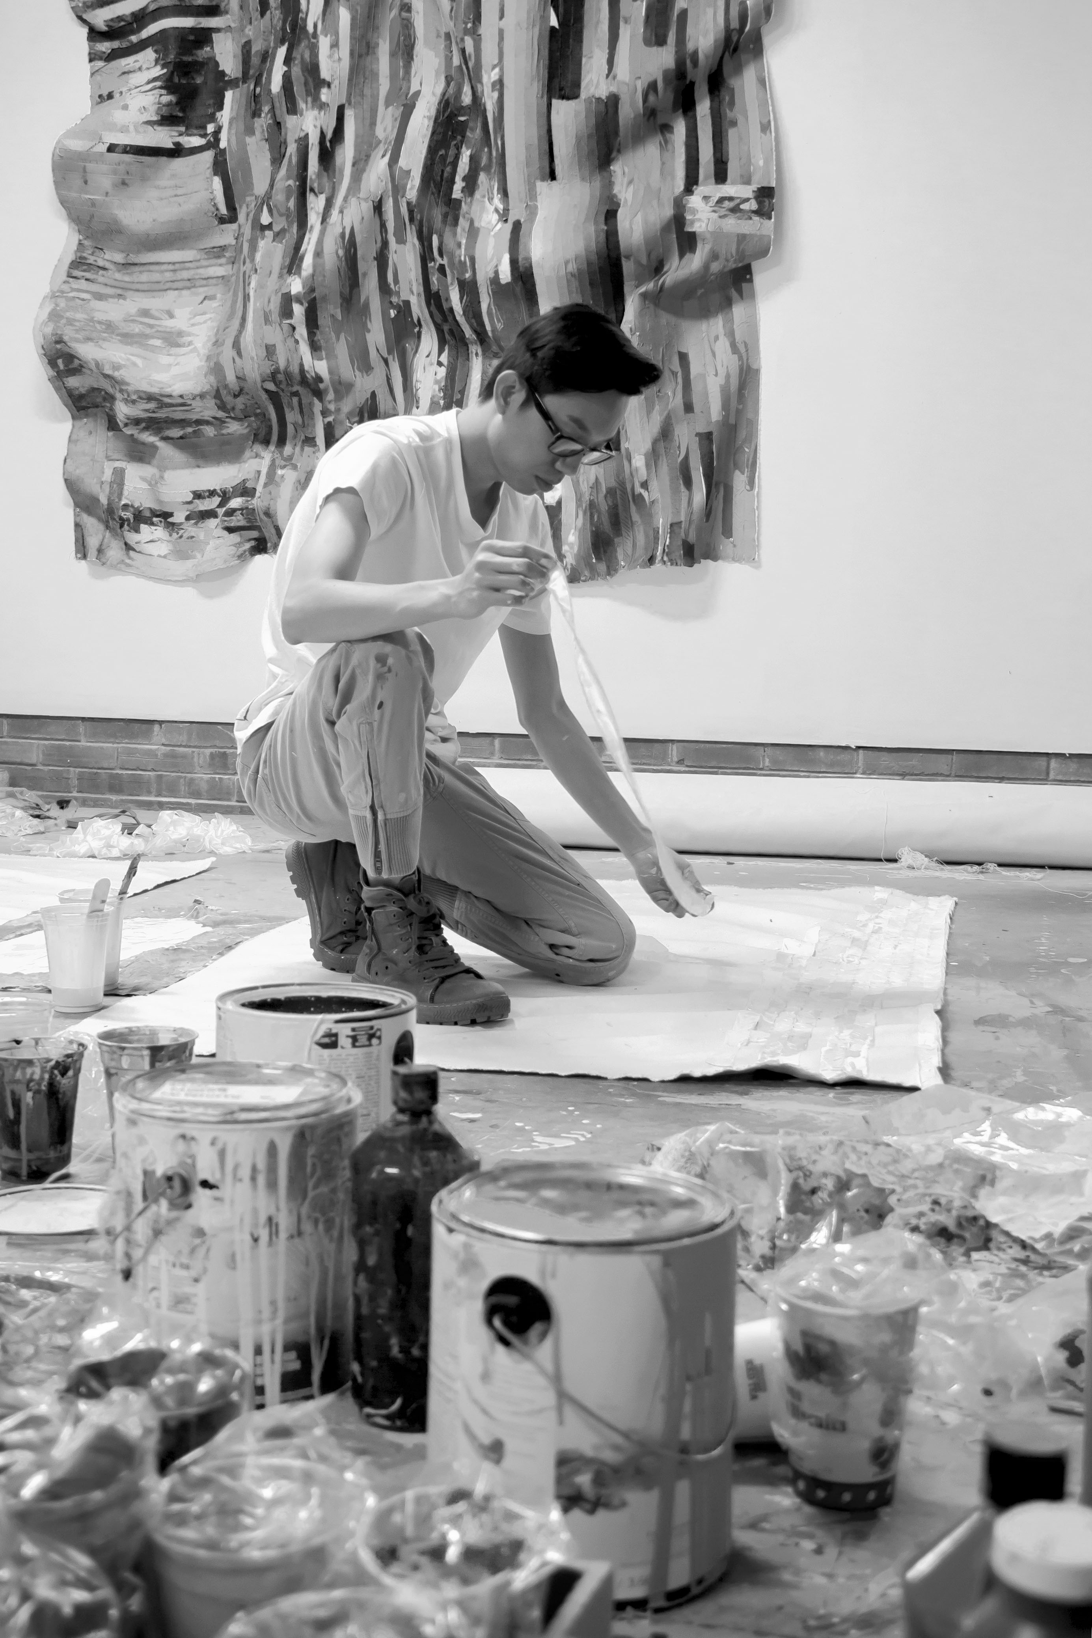
Kenny Nguyen creates what he calls “deconstructed paintings”, large, bold works that are comprised of hundreds of silk strips, which he cuts, paints, and meticulously applies onto canvas. The pieces may be hung in different iterations: sculpturally on the wall with undulations or flat, stretched like a painting on bars or behind glass. Born in Vietnam, Kenny moved to the states in 2010. After art school, he spent his early career in fashion. Working with silk has ties for the artist not only to dressmaking and patterns, but also long-standing associations to the material through his culture. The idea of cutting a fabric revered for its symbol of wealth, its beauty and delicacy in clothing, and its century-long ties to trade and status in Asia was a breakthrough for Nguyen. By taking something from tradition and reconstructing it, he was maintaining an association with his past while also making it is own. The process itself like the artist himself, a hybrid, blending cultures, and ideas, bringing to light the idea how identity is constantly changing over time, creating beauty and versatility.

His works have been exhibited at Sejong Museum of Art, Czong Institue for Contemporary Art, Seoul, South Korea, LaGrange Art Museum, GA, Florida State University Museum of Fine Art FL, Brownsville Museum of Fine Art TX, Capitol Hill Building D.C., Katzen Art Center at the American University D.C., Orange County Center for Contemporary Art CA, Art Market San Francisco, Seattle Art Fair, Frieze LA. In 2016, Nguyen received an Excellence Asia Contemporary Young Artist Award from Sejong Museum of Art. He was also awarded Artist Residency Fellowships from the Ragdale Foundation, Chicago, IL, The Hambidge Center, GA, Vermont Studio Center, VT, Gil Artist Residency, Akureyri, Iceland, Château d’Orquevaux, Orquevaux, France, AIR Guidiguada Gran Canaria, Spain.

